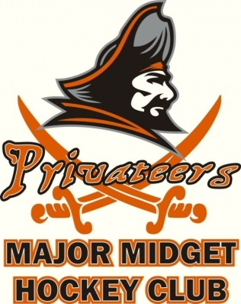
Social Media Policy

All Club Personnel and Players are reminded that giving, making, issuing, authorizing or endorsing any statements through social media or otherwise that: have or are designed to have an effect prejudicial to the welfare of the Privateers, the game of hockey, the NLMMHL or a NLMMHL Member Club; or are publicly critical of officiating staff may constitute a violation of the Privateers Code of Conduct and may be subject to disciplinary action.

Personnel and Players are reminded that any and all interactions in the online world are visible to media, scouts, coaches, and players everywhere. All members of the St. John’s Privateers are reminded to respect your audience and pause before posting. If you have to think twice about what you are posting, it is likely a good reason to err on the side of caution.

Respectfully,
Staff & Management
St. John’s Privateers Major Midget Hockey Club

